Assignment 1:
SET A
1. Write a Python program to read an entire text file.
Ans: from google.colab import files

# Upload file
uploaded = files.upload()

# Get the filename automatically
filename = next(iter(uploaded))

# Read and display the content
with open(filename, "r") as file:
print(file.read())
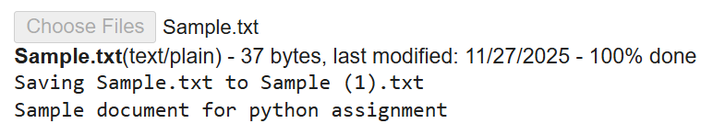
2. Write a Python program to compute the number of characters, words and lines in a file.
Ans: from google.colab import files

print("Please upload one or more text files (e.g. Sample.txt).")
uploaded = files.upload() # opens file picker

if not uploaded:
print("No files uploaded.")
else:
for filename in uploaded.keys():
try:
with open(filename, "r", encoding="utf-8") as f:
content = f.read()
except UnicodeDecodeError:
# fallback for other encodings
with open(filename, "r", encoding="latin-1") as f:
content = f.read()

# Number of characters (includes whitespace and newlines)
num_chars = len(content)

# Number of words (split on any whitespace)
num_words = len(content.split())

# Number of lines: splitlines() handles final line even without trailing newline
num_lines = len(content.splitlines())

print("\nFile:", filename)
print("Number of characters:", num_chars)
print("Number of words: ", num_words)
print("Number of lines: ", num_lines)
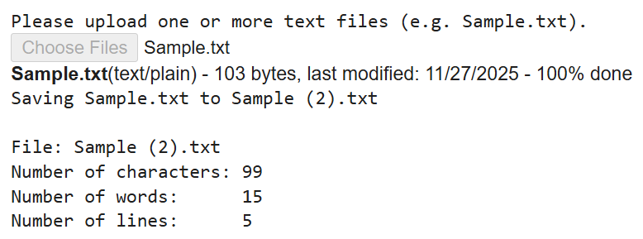
3. Write a Python script to print the current date in following format “Sun May 29 02:26:23
IST 2017”
Ans: from datetime import datetime
import time

# Get current date and time
now = datetime.now()

# Get local timezone name (e.g., IST)
timezone = time.tzname[0]

# Format the output
formatted_date = now.strftime(f"%a %b %d %H:%M:%S {timezone} %Y")

print(formatted_date)
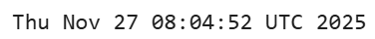
SET B
- Write a Python program to append text to a file and display the text.
Ans: filename = input("Enter the full path of the file: ")

try:
# Step 1: Append text to the file (creates file if it doesn't exist)
text_to_append = input("Enter the text you want to append: ")

with open(filename, 'a') as file: # 'a' mode creates file if missing
file.write("\n" + text_to_append)

# Step 2: Read and display updated content
print("\nUpdated file content:\n")

with open(filename, 'r') as file:
content = file.read()
print(content)

except Exception as e:
print("An unexpected error occurred:", e)
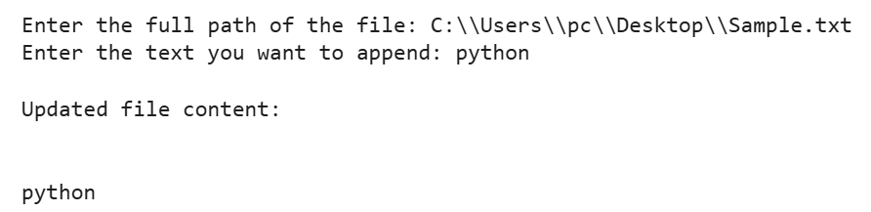

2. Write a Python program to print each line of a file in reverse order.
Ans: filename = "/content/Sample.txt" # change if needed

try:
with open(filename, "r") as f:
lines = f.readlines()

# Print each line in reverse order (characters reversed)
for line in lines:
print(line.strip()[::-1])

except FileNotFoundError:
print("File not found. Please check the filepath.")
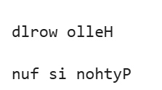
3. Write a Python program to print date, time for today and now.
Ans: from datetime import datetime, date, time

# Current date
today_date = date.today()
print("Today's Date:", today_date)

# Current time
now_time = datetime.now().time()
print("Current Time:", now_time)

# Combined date & time
now_datetime = datetime.now()
print("Date & Time Now:", now_datetime)
